3D Painting Art History Inspiration
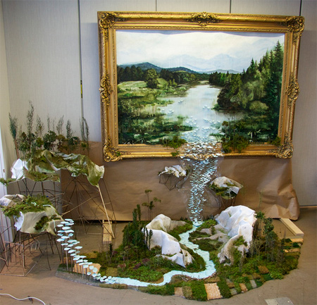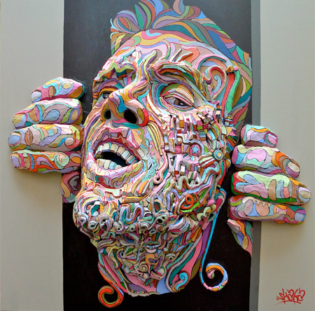
Gregory Euclide Shaka

Research a famous artist or art history style. Chose one of their artworks to replicate or use as an inspiration, and make your own composition.
If the artist’s artwork is 299 years old or newer you must crop the artwork and may only use 25% of the original composition (copy write laws).
Using assemblage construction, with cardboard and paper, you will create a three dimensional painting. You may use other materials to glue onto the surface to help with texture and creating actual space. The sculpture can either be a low relief or be much more sculpted into space.
Sculpture must be at least 8 inches by 10 inches for the base.
And at least 3 inches wide (the relief sticking out of the painting).

You must write down:
Artists Name: ___________________________________________________________
Date born/died: _________________________________________________________
Nationality: (where they are from) __________________________________________
Type of Medium Used: ___________________________________________________
Title of Artwork chosen for reference: _______________________________________
Date chosen artwork was made: ____________________________________________

Sculpture/Ceramics Project Assessment Rubric- Mrs. Tucker Gravatt
Student Name: | Class Period:
Project: 3D “Famous Art” Painting | Date: 2/15

Circle the number in pencil that best shows how well you feel that you completed that criterion for the assignment.  A= 56 - 60  B = 51 – 55  C = 46 – 50  D = 42 – 45  F = less than 41 | Excellent  (A)  Above standard | Good  (B)  Meets all standard objectives well | Average  (C)  Meets all standard objectives with help | Needs  Improvement  (D)  Below standard | Rate  Yourself | Teacher’s  Rating
Criteria 1: I understand the role of planning in solving artistic problems and have successfully selected a piece of “famous art” that interests me, cropped the image if necessary, and sketched plans to make the painting 3D. My sketch was approved with three views and I followed my plan. | 10 | 9 – 8 | 7 – 6 | 5, 4, 3, 2, 1
Criteria 2: I have successfully constructed and assembled my sculpture using cardboard and other found materials. Paying close attention to space and relief style I have also represented a foreground, middle, and background showing different elevations in space. | 10 | 9 – 8 | 7 – 6 | 5, 4, 3, 2, 1
Criteria 3: I understand the role of creating original artwork and showing visual expression. My form is painted to match the chosen artwork paying close attention to color and texture. | 10 | 9 – 8 | 7 – 6 | 5, 4, 3, 2, 1
Criteria 4: Technical Skill: How well have you executed the construction and painting skills for your form? Parts should not fall off, edges should be smoothed at joints of connection, etc. | 10 | 9 – 8 | 7 – 6 | 5, 4, 3, 2, 1
Criteria 5: Participation: How well have you put forth effort on this project? In class and outside of class on this assignment? | 10 | 9 – 8 | 7 – 6 | 5, 4, 3, 2, 1

Total Points Possible: 50 | Your Total: | Teacher Total:
Multiply by 2
Total Points Possible: 100

Written assessment worth -10 points total if not completed: (must be in complete sentences)
Write one strength about your project: (something you were successful or good at)
Write something you could improve on or would change about your project:
Write something you learned while completing this project:

