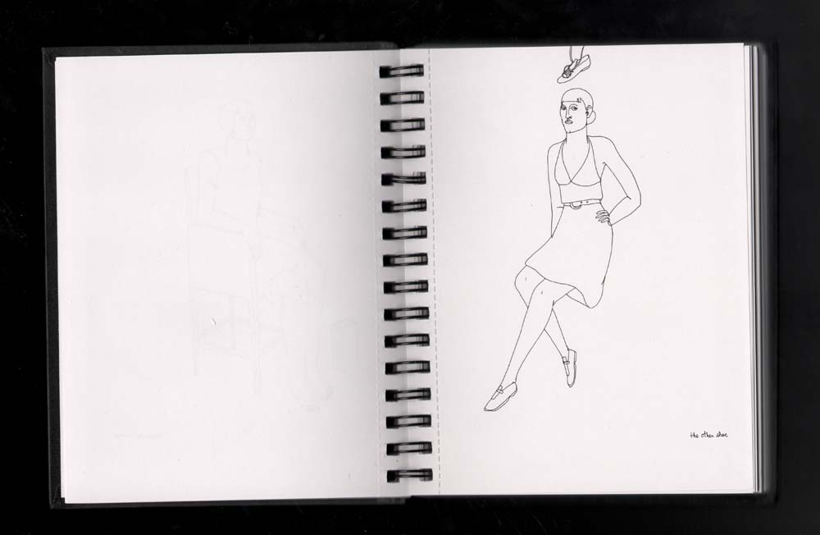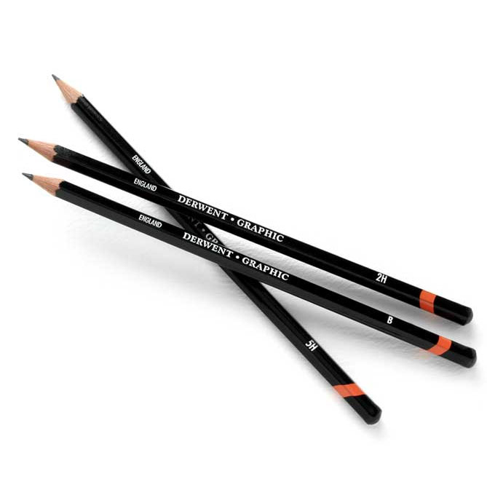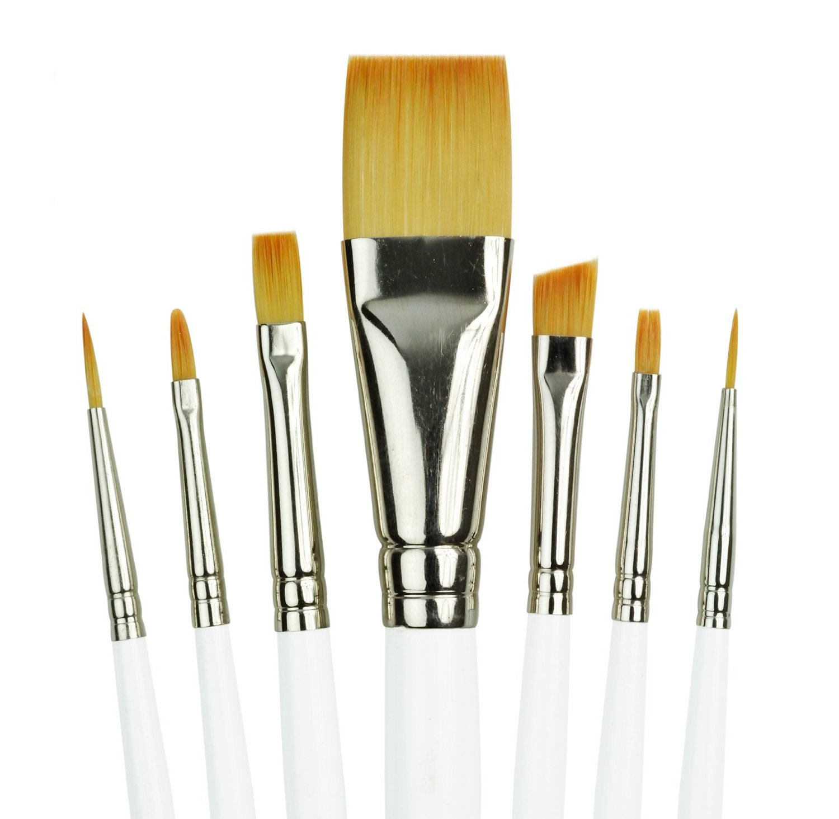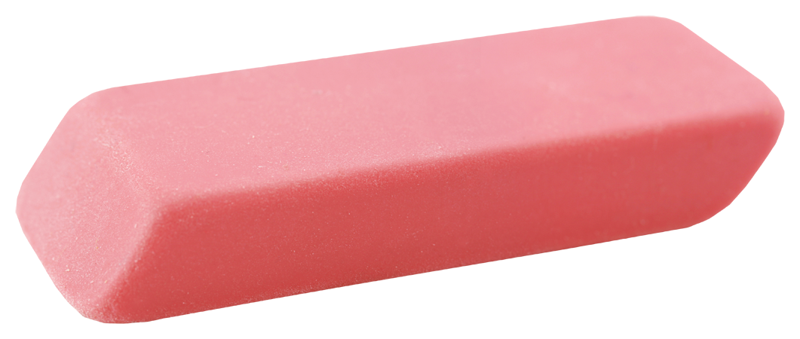

Sanderson High School, Raleigh NC Room 106 Office Hours: Thu 2:30-3:30

[atuckergravatt@wcpss.net](mailto:atuckergravatt@wcpss.net)

[www.tuckerartists.weebly.com](http://www.tuckerartists.weebly.com)

Remind App:

Text @atuckerg to 81010

* Positive Attitude, An open mind, Determination, Courage, and Creativity
* 9x12 or 8.5x 11 SPIRAL BOUND sketchbook (white paper, with NO lines) at least 50 pg.
* Wooden #2 pencils, may want pencil kit*

• Hand held pencil sharpener (not electric)

• Pink or white eraser and kneaded eraser

• Brush set for acrylic & watercolor and lidded container for paint

* Glue stick, mini stapler/ staples
* **Class materials are limited, any material borrowed from student must be used appropriately and returned or they will accrue a class fine.**
* **\*NO MATERIALS/ BOOKS MAY EVER LEAVE THE CLASSROOM**

Required Materials

*Creativity, Communication, Critical Thinking, Collaboration*

During this course you will be learning about and expanding your knowledge on the elements and principles of design and how to use them effectively. Through daily exercises in your sketchbook and work on projects, you will build technical skills in drawing and painting. You will work both collaboratively and individually on several projects throughout this course in 2D and 3D mediums.

### Beginning Visual Art

Abigail I. Tucker Gravatt

Art 1

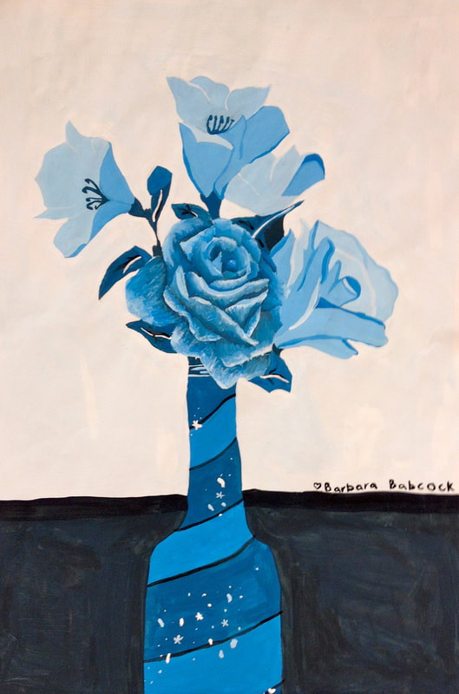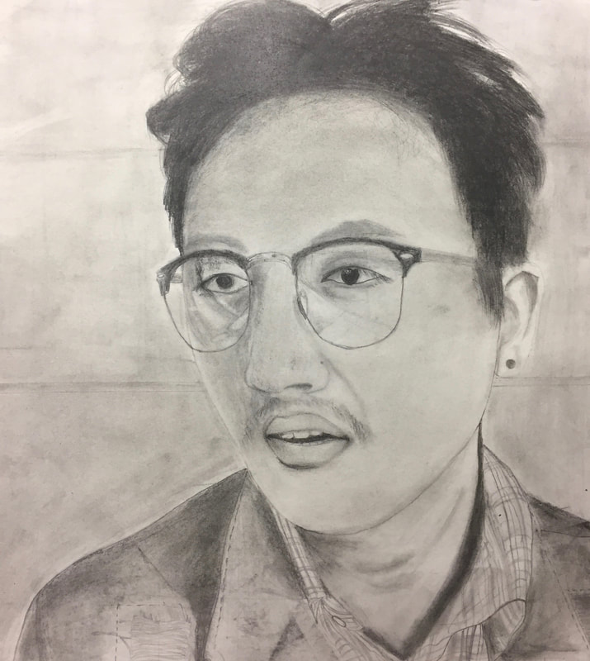[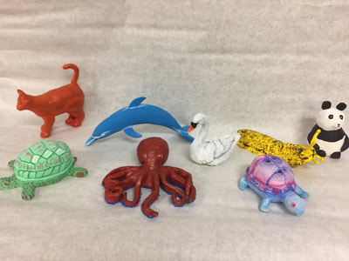](https://tuckerartists.weebly.com/uploads/1/4/3/5/14354280/img-2525_orig.jpg)

**Late Work/ Grade Recovery (Mastery):**  
Late Classwork & Visual Journals: Students will earn 80% of their earned grade. All late work only accepted up to one and half weeks past due date.   
Late Projects: Students have two class periods to turn in work (completed outside of class time) without receiving a penalty, after the two day grace period students will receive 80% of their earned grade. Ex. If student earned a B, they will get a C grade.   
Grade Recovery/ Mastery: If student is not satisfied with their project grade they may re-do the assignment and turn in again. Both earned grades will be averaged to make the new project grade. * only for projects.

**Make Up Work:** Students have **2 DAYS** to bring a note to the attendance office to receive an **EXCUSED ABSENCE**. It is the **STUDENT’S** responsibility to find out and make up any missed work. You will have **2 days extension** for each **excused** day absent. Work turned in late due to unexcused absences will count as late work.

- Be prepared  
- Be ready to learn  
- Work the entire class period  
- Respect classroom teacher/ peers/ materials  
- Push myself to excel  
- Keep studio space clean  
- Only use technology for class use

###### I will…

More detailed information on my website:

www.tuckerartists.weebly.com

Quisque sed magna.

## “I can!” Attitude required

#### Electronic devices are only allowed for classroom instruction.

Expectations