Ceramic Dream House Student name_______________________________
Ceramic Lesson: Slab building, Relief carving, piercing
Slab is a rolled out flat piece of clay. Slabs are either rolled out on a slab roller machine or you can use wooden dowels (to help measure height of slab) and rolling pins at your table. Make sure you flip clay in between each roll so it does not stick to the table or mat in the slab roller. Texture can also be rolled into the slabs by placing items on top of the clay and pressing them in, or rolling them in.
Relief is a type of sculpture that shows low elevation or depth difference between different grounds in the work. It is a very shallow representation of space. Relief sculpture in clay can either be carved away (subtraction method) or you can add thin layers of slabs (additive method).
Piercing is a type of subtraction method where you cut away sections or pieces of clay in the surface of the material you are using (clay in this project). When you pierce the clay it is important to support the clay on the opposite side you are cutting away from so the slab does not change its form.
Focus for this project: Emphasis, Contrast, and Balance.
Applying the elements of design you must show a strong emphasis, contrast and type of balance in your house sculpture.
*Remember that successful sculpture SHAPES SPACE in a meaningful way.
You must consider the relationship between positive space (sculpture) and negative space (space around sculpture).

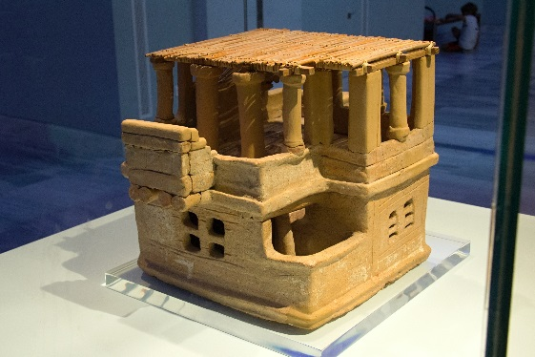  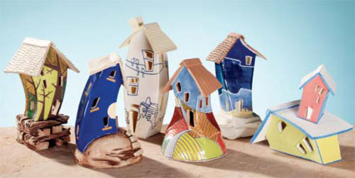  Carolina Pedraza | Rubric:  10= more than expected 9,8= met objective well 7,6= met objective with help, could improve 5= did not meet objective Rate yourself Teacher rating  House measures between 5-8 inches height and 4-6 inches diameter and has a unique form of the structure.  All rolled slabs are same thickness. Walls of house are constructed correctly- paying close attention to joints (straight or beveled)  A dominant emphasis is shown in the form of my house. I have visually balanced my form by repeating architectural elements.  I show strong contrast in my surface texture by demonstrating relief and piercing technique on my house.  Participation: I researched images on my own for reference. I followed my sketch plan. Worked the entire time given.  Total: 50x 2= 100 possible
**********Writing reflection: In at least three complete sentences describe your strengths, improvements, and things you learned while completing this project AND describe how you demonstrated the elements and principles of design that you needed to use for this assignment.
(-5pts if not completed correctly)

