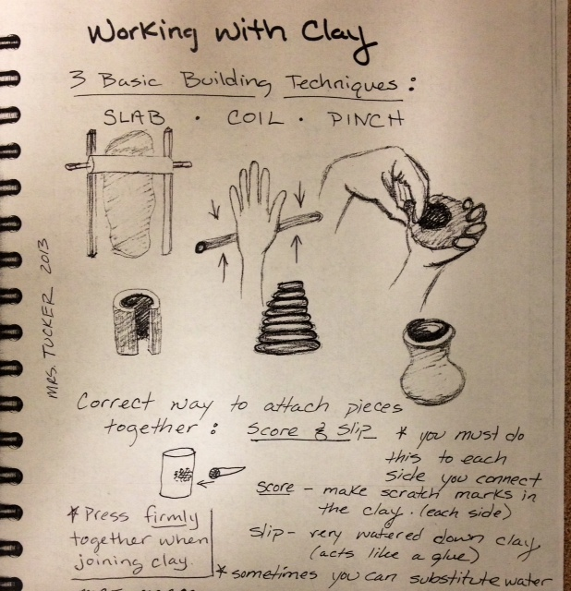
Greenware= unfired clay
Leather hard= when clay is partially dried and firm. Clay is cool to the touch and dark in color. This is the first stage of shrinkage. Pieces of clay can be joined at this stage as long as it is the same consistency. MAKE SURE CLAY DRIES OUT SLOWLY AND EVENLY WHEN YOU ARE FINISHED WORKING WITH IT- OR IT WILL CRACK AND FALL APART.
Bone dry= when all of the water has evaporated from the clay and is ready for bisque firing. Clay is warm to the touch and is light in color. Clay has shrunk completely before bisque shrinking. Clay is completely porous (can absorb water very quickly.) Be careful handling and do not sand (unless you have mask and eye protection) = clay at this stage is unhealthy to breath in. If exposed to too much clay dust over years you may develop silicosis (disease of the lungs.) Clay cannot be joined together at this stage!
Bisqueware or bisque fire= when the clay has been fired once at low temperatures (1720-1835 degrees; Cone 08-06.) Clay has now shrunk approximately 10-15% and is at it’s final size.
Glazeware or glaze fire= after clay has been bisque fired, clay is ready to be glazed and then fired again at a low or high temperature depending upon the glaze and clay body. At school we only use low fire glazes which fire between Cone 06-04.
Cones= numbers with a 0 in front are lower temperatures and the higher the number the lower the temperature= ex. Cone 04 is hotter than Cone 06. Numbers without a 0 in front are high fire clay or glazes and the higher the number the hotter the temperature.
Glaze= special type of paint with silica (sand material) and other minerals that when heated to the appropriate temperature will turn into a glass like surface. Most glazes in the classroom are non-toxic and food safe, make sure if you are making a dinnerware piece (that you can eat or drink out of) that you check the glaze container to see if it’s non-toxic.
- You must apply two to three even coats of glaze
- Never mix the glaze colors = they do not mix like paint (red and yellow will not make orange)
- Never glaze the bottom of you ceramic pieces unless it is a sculpture piece that is rounded on the bottom.
Wedge= before you start working with clay you must wedge the clay to remove all air bubbles. Wedging is compressing the clay by kneading the clay for several minutes.
* If air bubbles are left in the clay your clay will explode when it is fired.

Reconstituting Clay:
1 - Take bone dry clay and break it into small pieces or powder (wear mask if rolling into dust)
2 - EITHER put pieces of dry clay into the slack bucket to soak overnight and become completely saturated with water again. Make sure water level just covers the clay. Or... take dry clay powder and mix in a bowl-add a little water at a time until clay is the right consistency.
3 – Take clay out of the slack bucket (it should be completely mushy and break apart easily). Place a 1-2 inch layer of clay on a plaster batt and let dry slightly for one day. Make sure clay is covered over night and it may need to be flipped to evenly dry on both sides.
4- Take clay off plaster batt and put in the gray recycled clay bucket or wedge and use.
* REMEMBER clay needs to always be covered tightly and not exposed to air or it will dry out!

