Coil Pot Ceramic Lesson
Coils are rolled tubes of clay. Coil pots show strong texture and design. Artsits choose to smooth out coils on one side of the sculpture for support and difference in texture, or leave them as is. You would not smooth out both sides of coil texture- this would look like a pinch pot.

Coiling is a method of creating pottery. It has been used to shape clay into vessels for many thousands of years. It ranges from Africa to Greece and from China to New Mexico. They have used this method in a variety of ways. Using the coiling technique, it is possible to build thicker or taller walled vessels, which may not have been possible using earlier methods. The technique permits control of the walls as they are built up and allows building on top of the walls to make the vessel look bigger and bulge outward or narrow inward with less danger of collapsing.

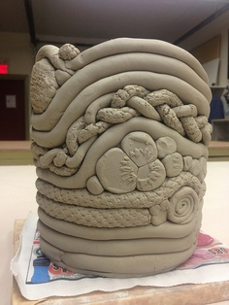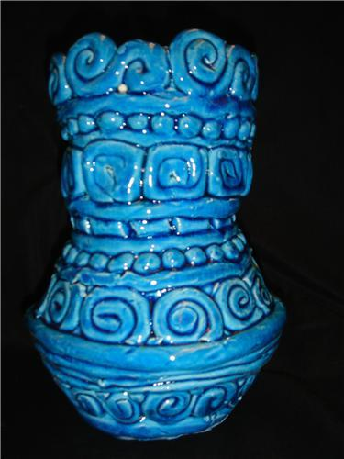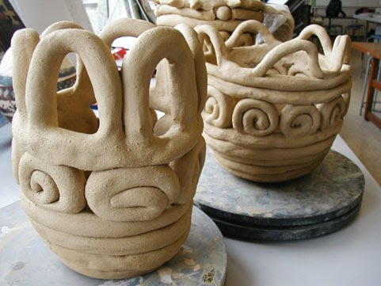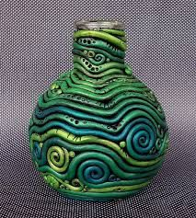

Student Name: _____________________________________________________________
10= more than expected  9= met objective well  8= met objective with help, could improve  7= did not meet objective | Rate yourself | Teacher rating
Coil pot measures approximately 4 inches diameter on bottom (top may be different) and 6 inches height. The body of the coil pot has an interesting form, not just a straight cylinder.
You have used at least three different types of coils throughout your coil pot design to create a visual RHYTHM with the use of LINE. Vary the thickness for visual interest, remember lines are not always solid.
Coil design is neat and carefully constructed. Coils are solid with no breaks or cracks, and are not flattened on the outside of your pot. Thickness of coils is between ¼ inch and ½ inch. Coil pot is constructed carefully and will not break apart.
You have incorporated one symbol in your design that represents something about you. This may not be in line form, must be easily recognizable as a symbol. Be creative!
Participation: did you research images on your own for reference? Did you follow your sketch plan?
Total: 50 possible Multiply by 2 for your final score= 100 possible

**********Writing reflection: In three complete sentences describe your strengths, improvements, and things you learned while completing this project. What is the symbol you added? And how does it represent something about you? (-10pts if not completed correctly)

