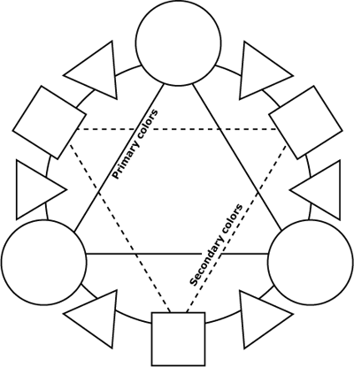

Using the above template label all primary, secondary and intermediate colors. Using watercolor, paint each hue in the appropriate space. Mix colors on the side of the pan, not directly in the color pot if using pan colors. Make sure you have an even amount of water and color is not too light, but also it doesn’t remain sticky. If color doesn’t dry on paper, you didn’t use enough water.

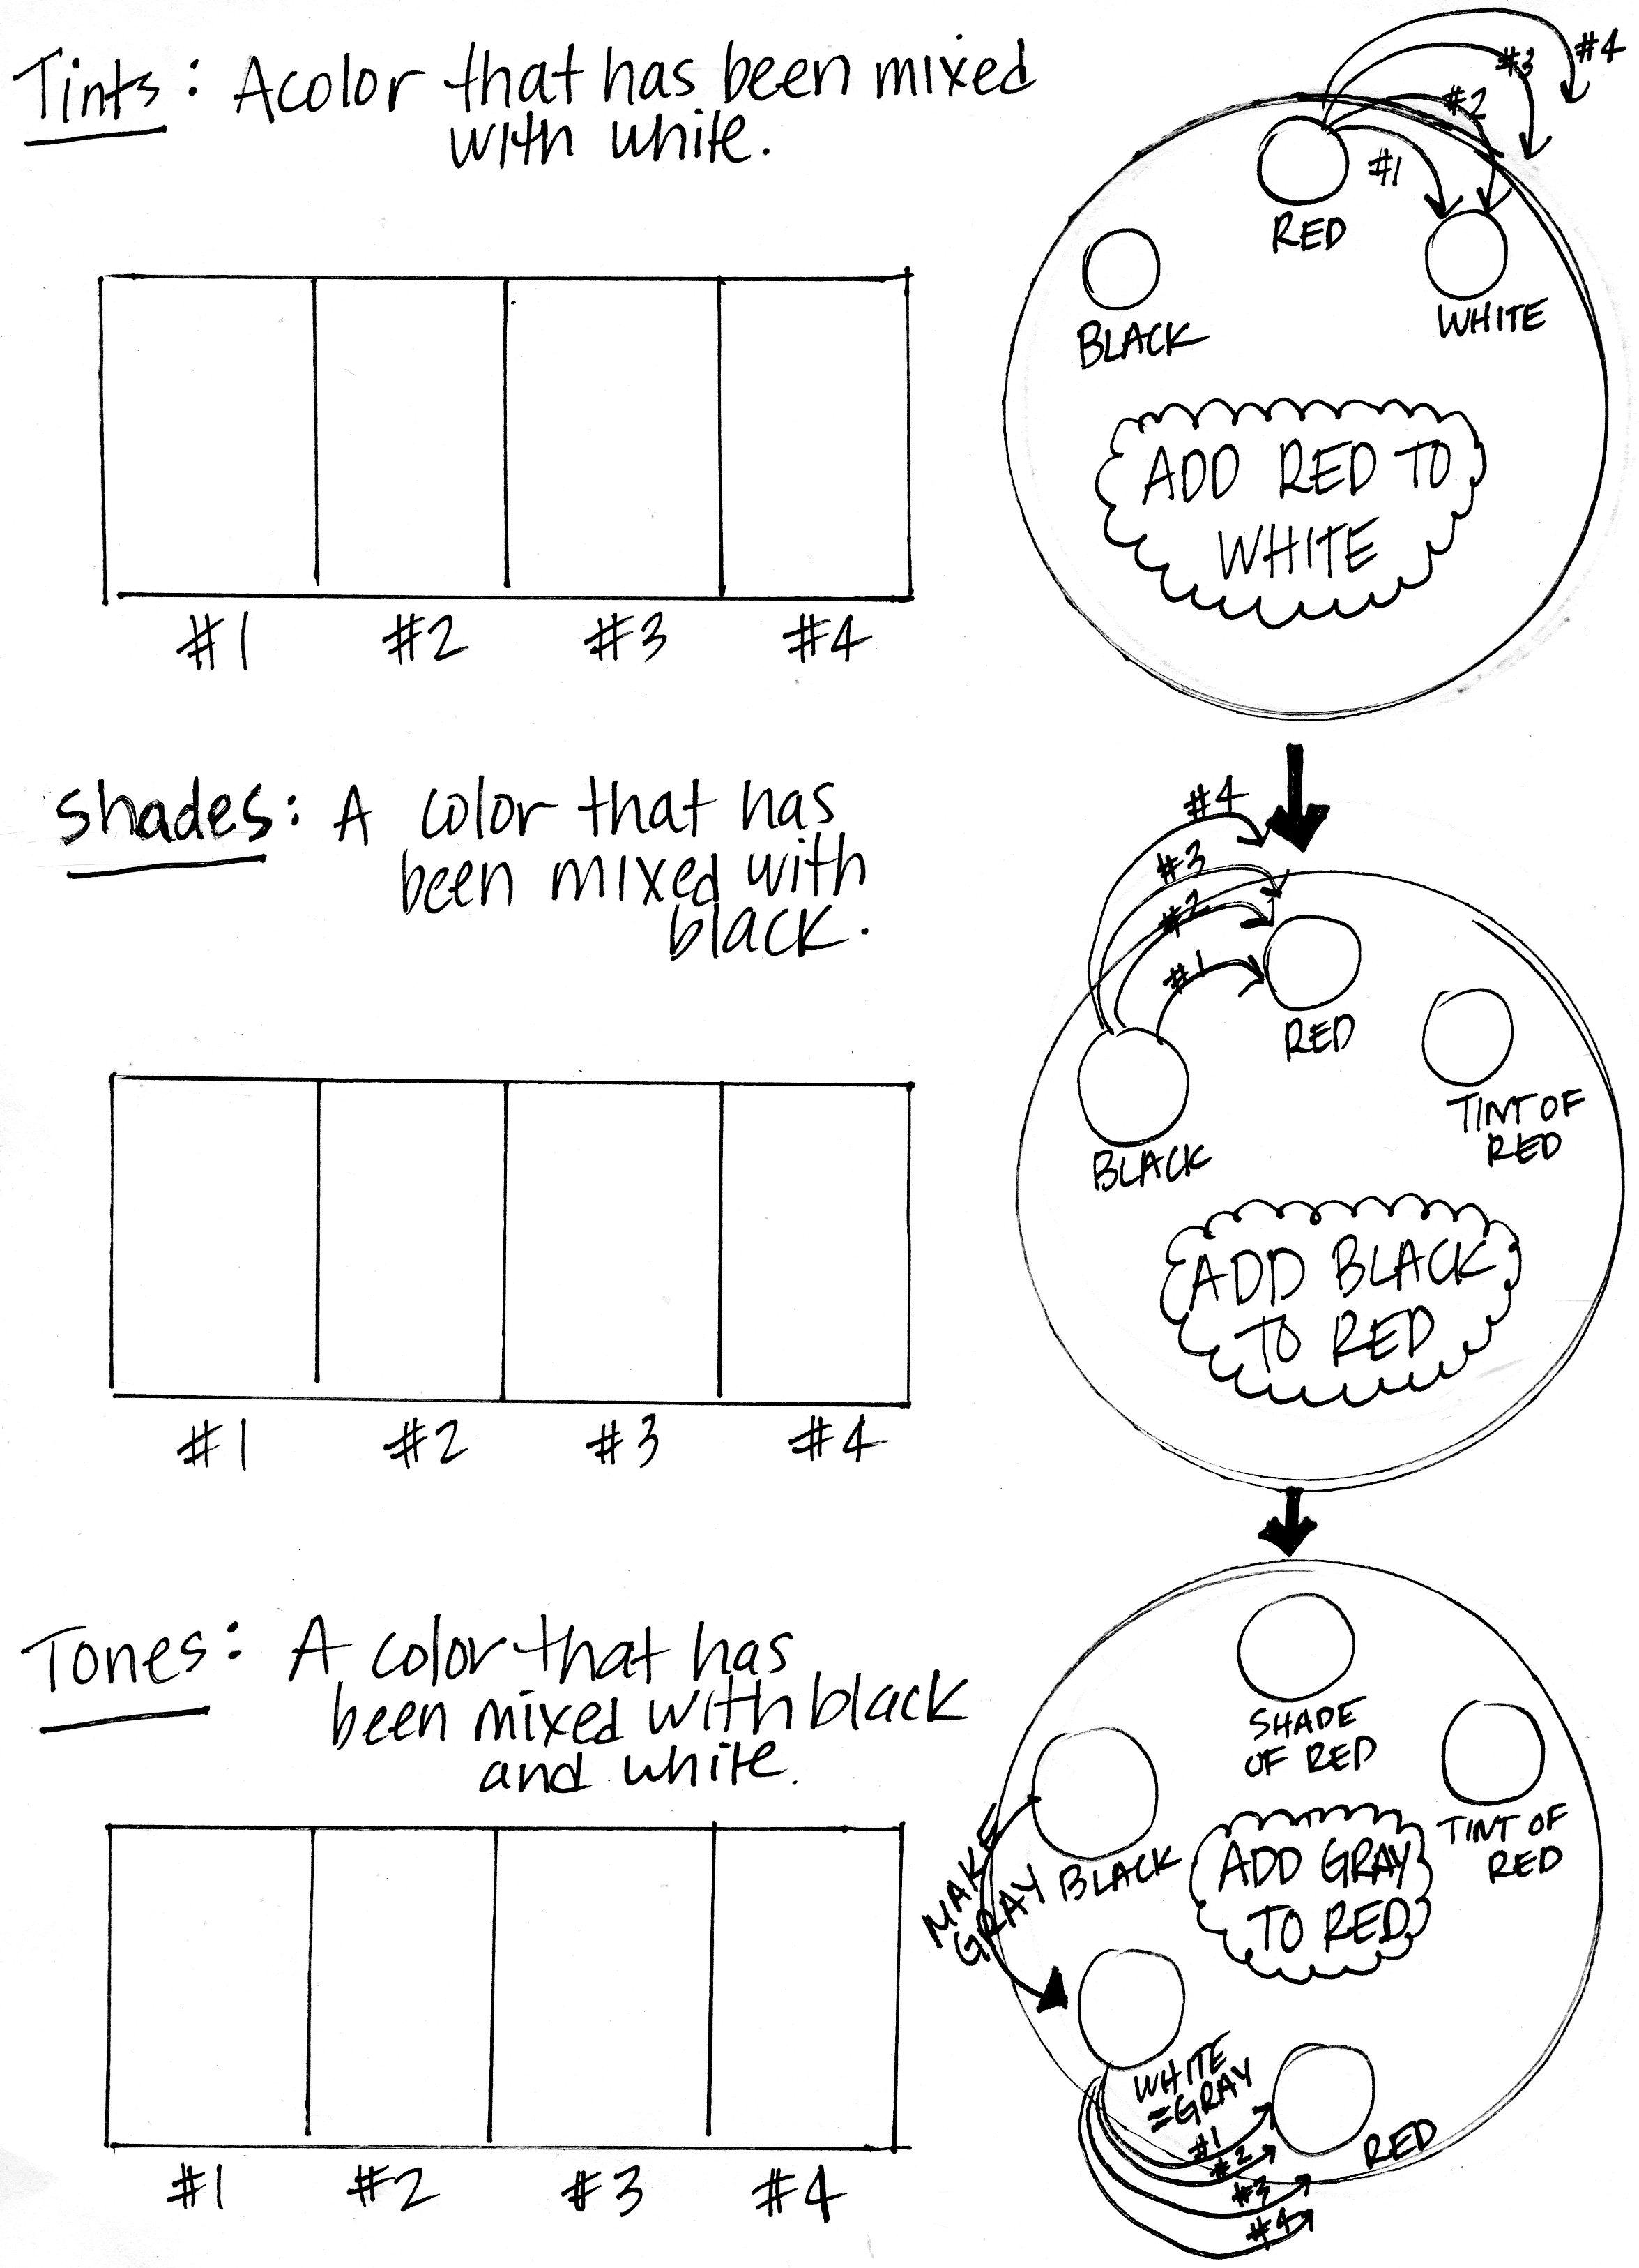
Using tempera or acrylic paint, complete the above tints, shades, and tones. You may use red, yellow, or blue as your pure color. Must use same color for whole page. Do not mix water with your paint, as this will make it translucent, water is only for washing brushes. Make sure your brush is completely dry before using it.

