Cross Contour Line and Blind Contour Portrait Collage
Cross contour lines follow across the planes on a form. They follow the curves and valleys across the surface to show the form with line.

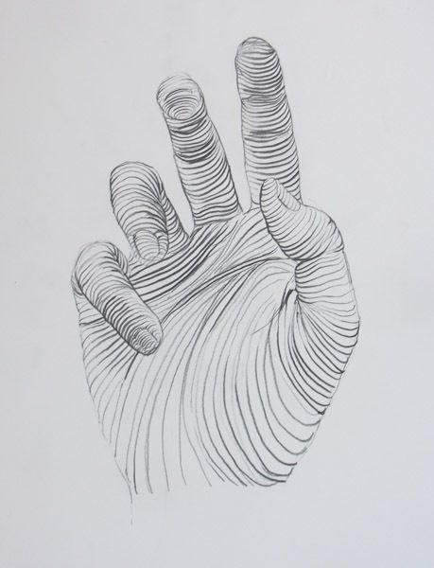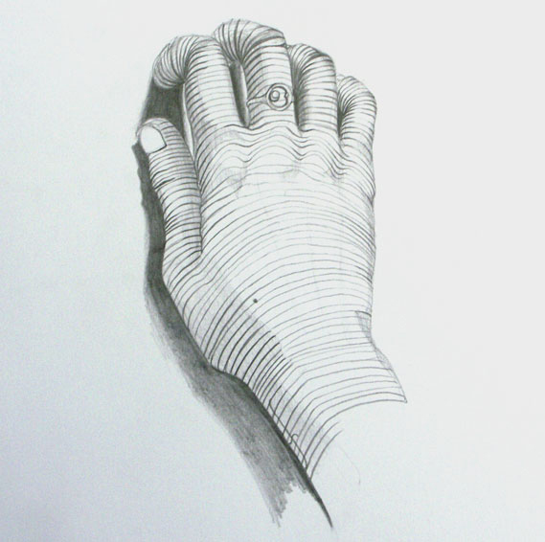
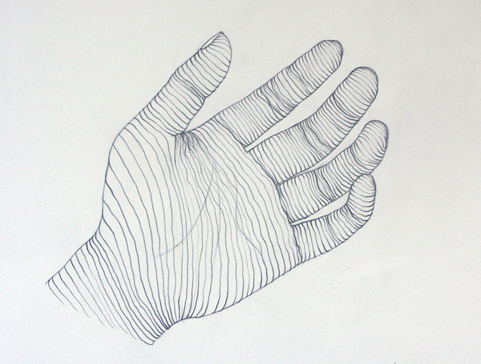

Practice drawing cross contour lines on overhead sheet that is placed over a picture of a hand. Pay attention to the curves of each finger and across the contours of the palm. Then, on one whole sketchbook page lightly draw your hand with contour lines. Then use pen or marker to draw lines that cross over and through your hand to show the different planes. Use different curved lines that start on one edge and cross over to the opposite edge of your outline to show the form.

Blind Contour line drawings are contour line drawings that you only look at the subject you are drawing and never look at your paper. It’s helpful to cover up your hand and drawing so you don’t cheat.

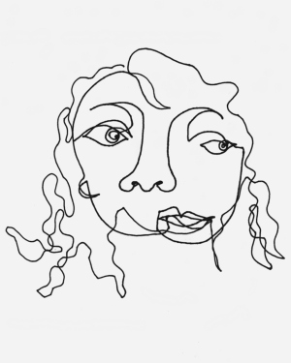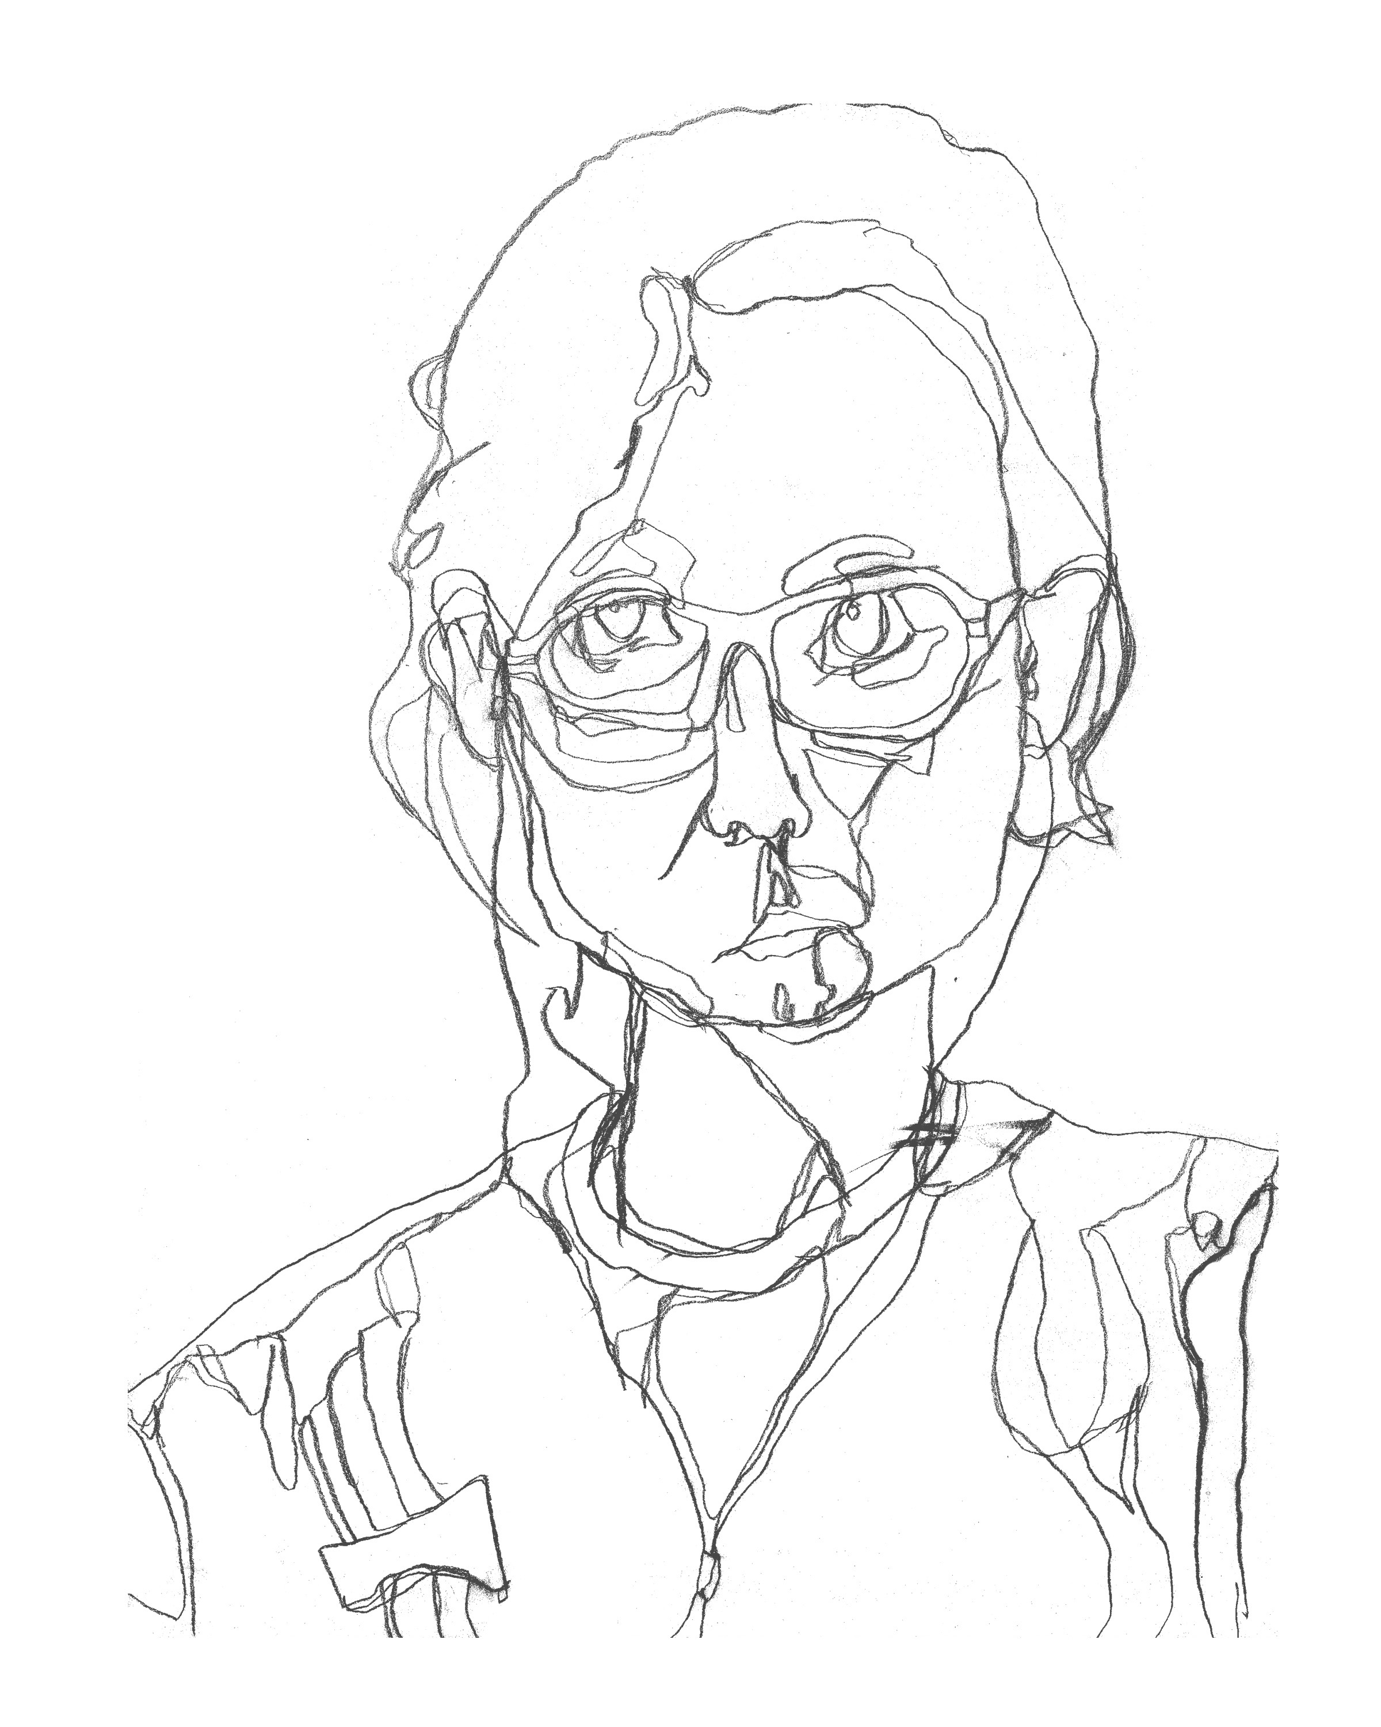

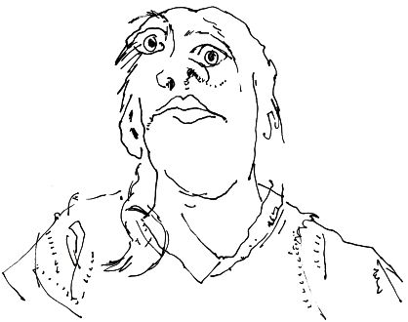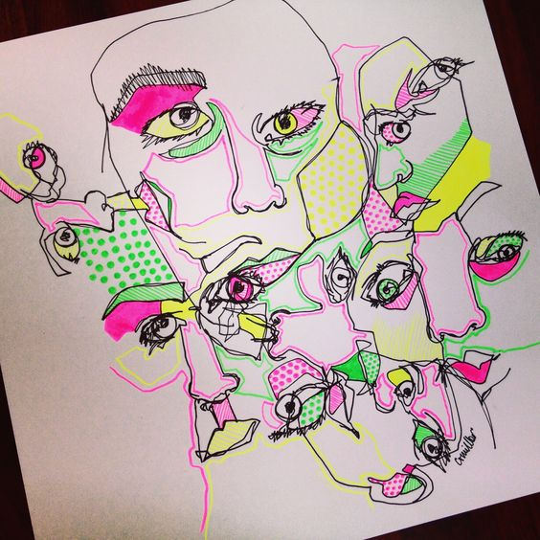

Using one whole sketchbook page, draw each person at your table (at least 3) using blind contour drawing technique. For each drawing change the orientation of the paper (turn it.) Drawings of each person should over lap. Use a different color pencil or marker for each person for easy differentiation.

