Dinnerware Set of 4 Functional Pieces
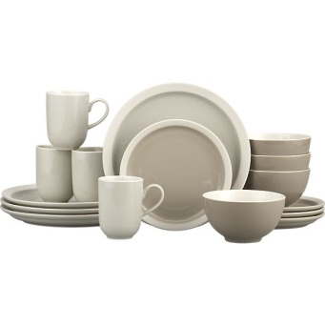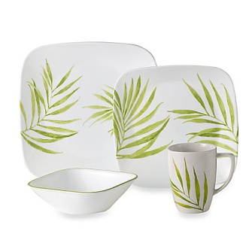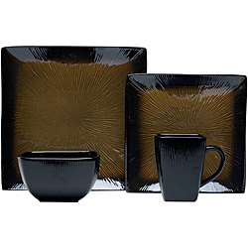
Crate & Barrel Bed Bath & Beyond Overstock.com

Sculpture 2 Project Assessment Rubric- Mrs. Tucker Gravatt
Student Name: | Class Period:
Project: Ceramic Dinnerware Set of 4 | Date:

Circle the number in pencil that best shows how well you feel that you completed that criterion for the assignment.  A= 90-100  B = 80-89  C = 70-79  D = 60-69  F = less than 59 | Excellent  (A)  Above standard | Good  (B)  Meets all standard objectives well | Average  (C)  Meets all standard objectives with help | Needs  Improvement  (D)  Below standard | Rate  Yourself | Teacher’s  Rating
Criteria 1: I understand that art making involves planning and precision. I have successfully sketched my plans including measurements, multiple views to show form, and surface texture. I have carefully considered the shape of the form of each piece before I start construction. | 20 - 18 | 17- 16 | 15- 14 | 13- 12
Criteria 2: I have constructed 4 dinnerware pieces including at least one plate (with foot or flange to pick up), and one bowl, and one cup/mug. All pieces have a consistent body form and visually match as a body or family. Each piece is made with the intention that it will be functional and must be appropriate size and feel right when held. *may also include utensils. | 20 - 18 | 17- 16 | 15- 14 | 13- 12
Criteria 3: Using my creativity, I have created a unique design for my dinnerware and used a contrast of surface design and texture to show emphasis. | 20 - 18 | 17- 16 | 15- 14 | 13- 12
Criteria 4: Technical Skill: How well have you executed the construction skills for this assignment? | 10 | 9 – 8 | 7 – 6 | 5, 4, 3, 2, 1
Criteria 5: Participation: How well have you put forth effort on this project? In class and outside of class on this assignment? | 10 | 9 – 8 | 7 – 6 | 5, 4, 3, 2, 1

Total Points Possible: 80 | Your Total: | Teacher Total:
Written Points Added below Possible: 20
Combined Total for Final Grade: 100 Possible

Write a reflection on elements/ principles used, strengths and improvements for this project on the back of rubric. 3 complete sentences.

