Drawing Forms

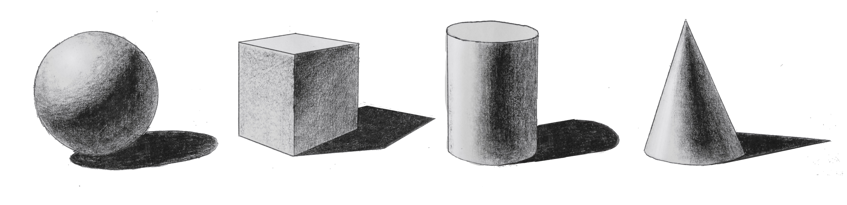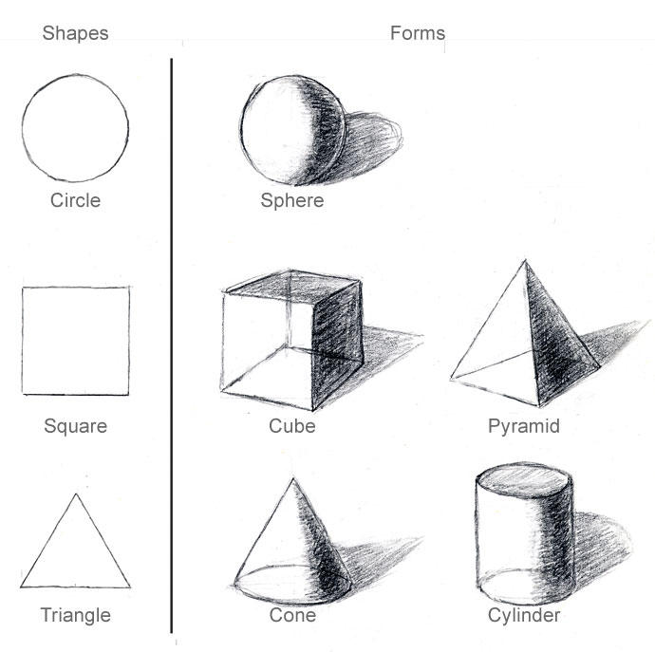

Geometric Form: Practice drawing a Sphere, Cube, Cylinder, Cone and Pyramid on one whole sketchbook page, by setting up a still life on your table and drawing real forms. Forms must fill the entire space provided. Each form must have the same light source, smooth blended value with a pencil and a shadow. Do not outline the forms, value must transition to show the form. These simple forms are in every complex form, and if you practice how to do this correctly you can learn how to put forms together and draw anything! (1 Day)

Organic Form: Practice drawing organic forms from life. Forms will be provided by teacher. Remember to look for geometric shapes within the form to help get proportions correct. Look carefully at the value transitions. Do not outline the object. Drawing should take up one entire sketchbook page. (1 day)

Use the above Value scale to check if you are applying enough value throughout your entire drawings.

