Culture Collage in the style of Eric McRay- Raleigh, NC Artist
Watch the following videos from YouTube:
- Eric McRay/ Men at Art/ Black Issues Forum/ UNC-TV : https://youtu.be/RjMqmgGJ-bw
- Thelma Golden; How art gives shape to cultural change/ TED Talk: https://youtu.be/EGjxI_5MPUY
And view Eric McRay’s web site: http://ericmcray.com/

Objective: You will be creating two collages based on your culture using a variety of mixed media.
Culture Definition:
1. the quality in a person or society that arises from a concern for what is regarded as excellent in arts, letters, manners,
scholarly pursuits, etc.
2. that which is excellent in the arts, manners, etc.
3. a particular form or stage of civilization, as that of a certain nation or period: Greek culture.
4. development or improvement of the mind by education or training.
5. the behaviors and beliefs characteristic of a particular social, ethnic, or age group: the youth culture; the drug culture.
6. Anthropology. the sum total of ways of living built up by a group of human beings and transmitted from one generation to
another.
Collage: a visual art technique where multiple different forms are assembled to create one new form.

- Answer the following questions on a separate piece of paper (this is a separate classwork grade)
How would I describe my culture? (Focus on definitions 5 and 6 from above)
In what ways does my culture/ heritage affect my life?
How has my cultural view changed from my parent’s generation?
What will my ancestors think of me?
What makes me a unique individual?
Do you feel like your culture is an important part of your life?
Do you base daily decisions on cultural norms?

- Attach metaphors or symbols to answers. Begin by looking through magazines for images that relate to your answer and the metaphors or symbols you identified. If you can’t find the specific image you can “weave” colors or images together to make the one image, ex. Using several reds to create a barn.
- Narrow down to two of the 5 questions that you are having the most success finding images for.
- Create 2 collage-based artworks that you will add multi-media layers to (paint, pastel, paper, fabric, yarn, found objects, dried beans, rice, etc). Be creative with your choice of materials to use, can you use fabric for people’s clothing? Wallpaper scraps on the walls of rooms? Rice to make grass texture and then paint? Part of Eric's process is to work on multiple pieces at a time so that you don't get stuck on one certain thing, set it aside and move to the other one.
- For each artwork you will be working from the background to the foreground. You must construct these in layers; you should have a minimum of 3 layers covering the entire design of each collage.
- DO NOT GLUE ANYTHING DOWN UNTIL YOU HAVE FIGURED OUT YOUR ENTIRE COMPOSITION!
- REMEMBER TO USE THE ELEMENTS AND PRINCIPLES OF DESIGN TO BALANCE YOUR WORK AND ENGAGE THE VIEWER TO A FOCAL POINT AND TO TELL A STORY OF WHAT IS HAPPENING IN THE IMAGE. WHAT ARE YOU TRYING TO VISUALLY COMMUNICATE?
- One of your collages will ultimately become a stronger composition and this is the one you will turn in for a grade. You will turn in both for credit, but only one will be graded.

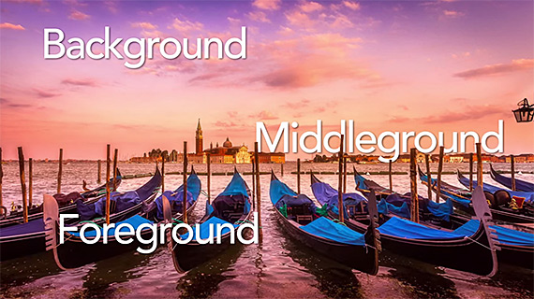 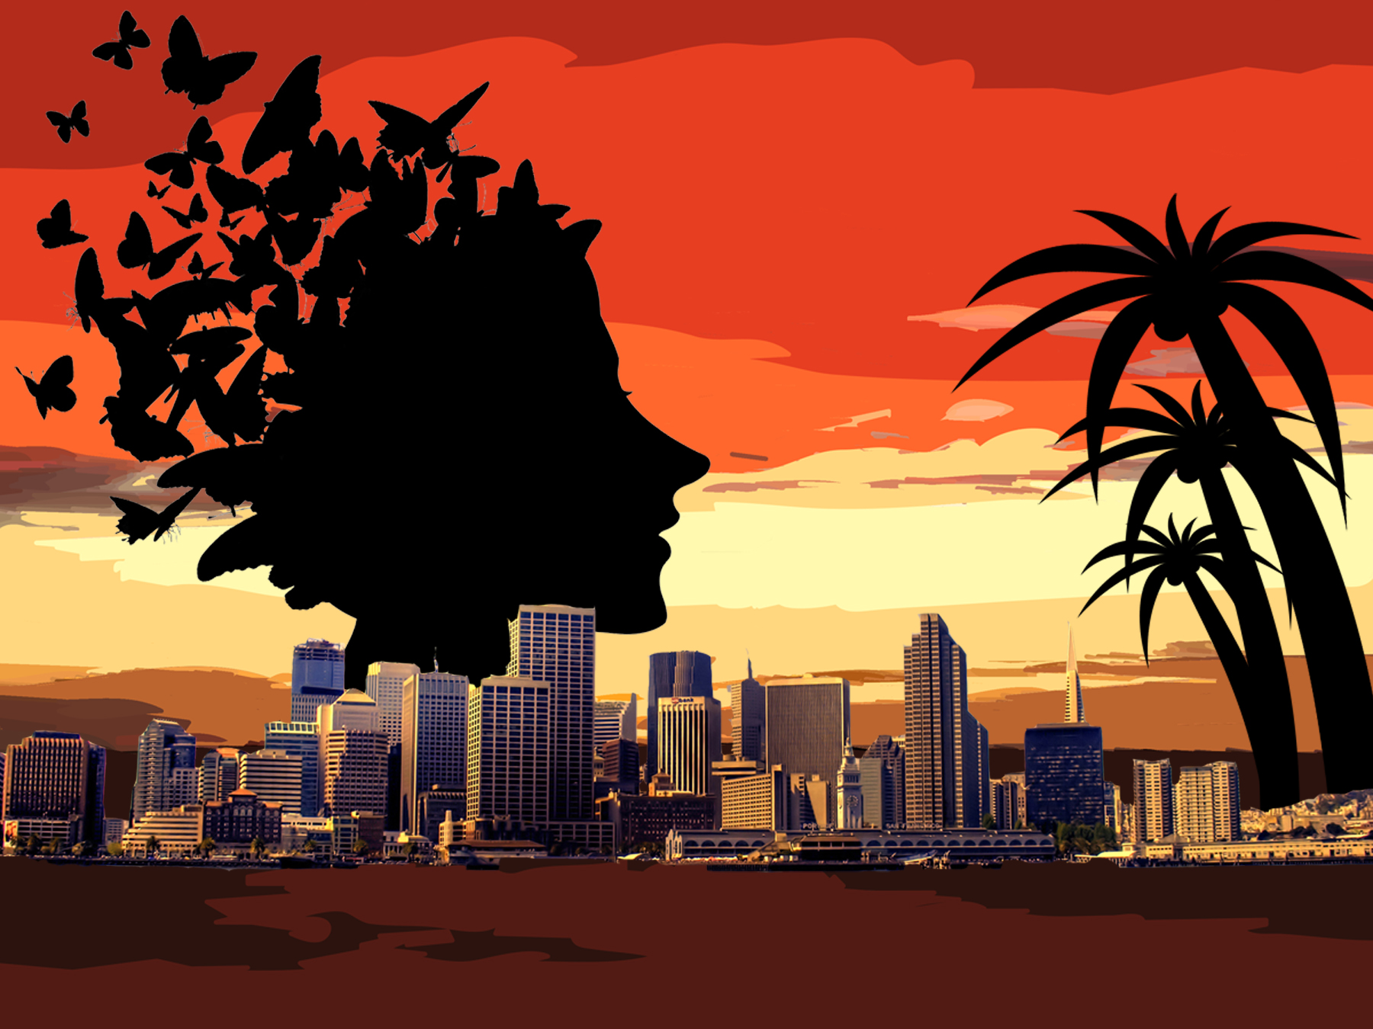 ICA Teens
Look up images of collage artwork online for inspiration before you start planning.
Objective Standards  Student Name:____________________________________ | Student Score  (1: does not meet standard- 20: excels standard) | Teacher Score  A: 20-19, B: 18- 17, C: 16- 15, D: 14-13, F: below 12
I understand the proper use of space by utilizing the elements and principles of design and have shown a background, middle ground, and foreground with at least 3 different layers in collaging throughout my entire design.
I understand the importance of having variety and contrast and have used a variety of different textures through use of different media (paper, paint, yarn, fabric, etc.) and still maintain Unity throughout the design.
I understand that art is a visual language and have told a story about my cultural significance through symbolism and design that is emphasized by a focal point through the use of the elements and principles of design.
How are the technical skills and craftsmanship?
Participation: Did you work the entire time on your design in and outside of class to be successful? Did you include reference pictures for your design?
TOTAL: (100 possible)
Written reflection (-10 if not completed)
What is in your foreground, middle ground, and background? Why did you choose these objects to be in your collage?

What different materials did you use in your collage and how did you show unity in your design?

In your artwork; what are you visually telling about your culture and how it is significant to you?

