Face Jugs “mug”
Student name________________________________________
Ceramic Lesson: Pinch Pots
Pinch Pot is a vessel, which is constructed by pinching clay together and molding it with your hands.
“Face jug” is a term coined by decorative arts historians to refer to an African American pottery type created in the second half of the nineteenth century, in the midst of slavery, in the Edgefield District of South Carolina. The small vessel is turned stoneware with facial features—wide eyes and bared teeth—made of kaolin, locally sourced clay.
Historians originally believed that the face jug was utilitarian and used to store water. Multiple theories later surfaced involving its function as a container of magical materials and its ritualistic use. New research has shown that the vessel was likely multipurpose—and a coded object meant to be misunderstood.
White potters appropriated the face jug design around 1880. They mainly discontinued the use of kaolin, a sacred material in West Africa, and produced the objects mostly as whimsies. The face jug thus lost the symbolic power of its original form.
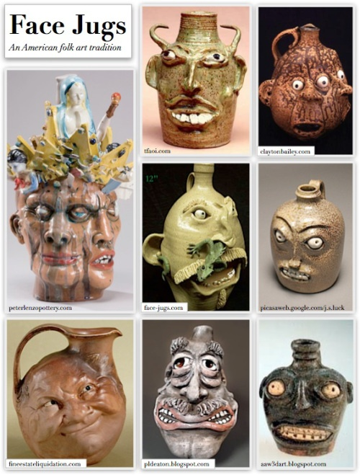 | Rubric:  10= more than expected 9,8= met objective well 7,6= met objective with help, could improve 5= did not meet objective Rate yourself Teacher rating  Mug measures approx. 5 in height, 3 in diameter  Face is proportional and realistically constructed. It is built correctly with pinch technique  You have clearly expressed a strong emotion in face, showing character and creativity  How are your technical skills?  Participation: did you research images on your own for reference? Did you follow your sketch plan?  Totals: 50 (x2)= 100 possible
**********Writing reflection: In three complete sentences describe your strengths, improvements, and things you learned while completing this project (-5pts if not completed correctly)

