Visual Art 1 Project Assessment Rubric- Mrs. Tucker Gravatt
Student Name: | Class Period:
Project: Floral Still Life | Date:

Circle the number in pencil that best shows how well you feel that you completed that criterion for the assignment. | Excellent  (A)  Above standard | Good  (B)  Meets standard objective well | Average  (C)  Meets standard objective with help | Needs  Improvement  (D)  Below standard | Rate  Yourself | Teacher’s  Rating
Criteria 1: I have successfully drawn a vase of flowers from a still life (real life observation). My composition is arranged successfully engaging the whole space of the paper. I have approximately used 50/50% with figure and ground. | 20 | 19 – 18 | 17 – 16 | 15 or below
Criteria 2: I have carefully paid attention to detail and shapes in each flower to show diversity and texture in each type of flower. I show a range of value throughout to show proper forms. | 20 | 19 – 18 | 17 – 16 | 15 or below
Criteria 3: B.V.2.3 I have used my creativity to create a specific mood in my artwork with color and used one type of color family in my artwork (complimentary, monochromatic, analogous, etc.) I have successfully blended paint to create depth and a wide range of hue and value. Minimum 10 different hues used across the entire composition. (NO AREAS WITH ONLY ONE COLOR USED! MUST BLEND ON TOP OF EACH OTHER) | 20 | 19 – 18 | 17 – 16 | 15 or below
Criteria 4: Technical Skill: How well have you executed the drawing and blending skills for completing this artwork? Did you draw your flowers to scale and pay attention to proportion? Attention to detail and showing different texture/ value/ and hues? | 20 | 19 – 18 | 17 – 16 | 15 or below
Criteria 5: Participation: How well have you put forth effort on this project? In class and outside of class on this assignment? I had my sketch approved before I started my final drawing. | 20 | 19 – 18 | 17 – 16 | 15 or below

Total Points Possible: 100 | Your Total: | Teacher Total:
Written Points Added below Possible: -10 if not completed
Combined Total for Final Grade: 100 Possible

Written assessment worth 10 points total: (must be in complete sentences)
In one paragraph describe one strength, one improvement, and something you learned while completing this project. List elements or principles that are dominant and how they enhance your artwork.

Pablo Picasso
Born in Málaga, Spain, in 1881, Pablo Picasso, became one of the greatest and most influential artists of the 20th century and the creator (with Georges Braque) of Cubism. A Spanish expatriate painter, sculptor, printmaker, ceramicist and stage designer, Picasso was considered radical in his work. After a long prolific career, he died on April 8, 1973, in Mougins, France.

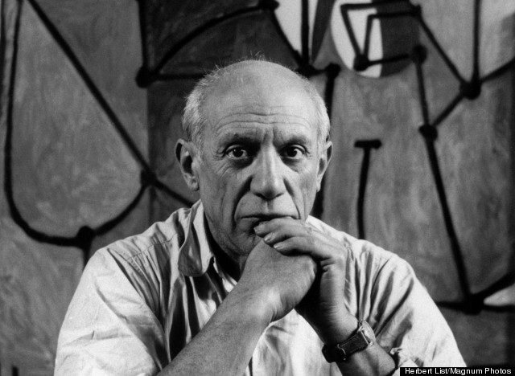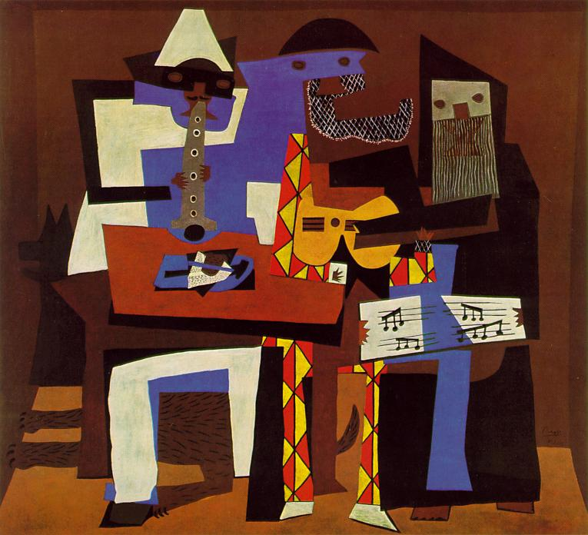
Picasso Three Musicians,1921 oil

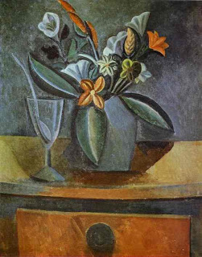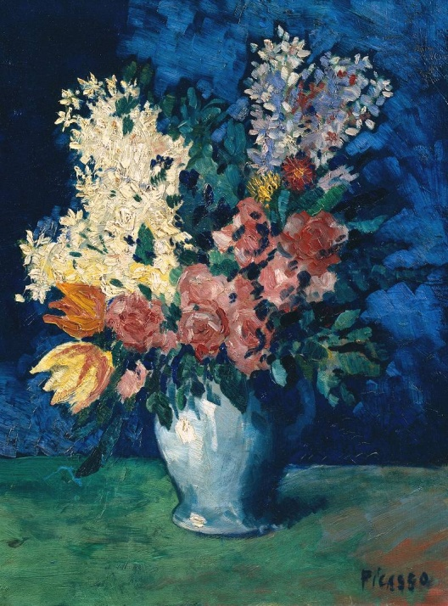
Flowers in Gray Jug with wine glass and spoon, 1908 Flowers, 1901, oil painting

