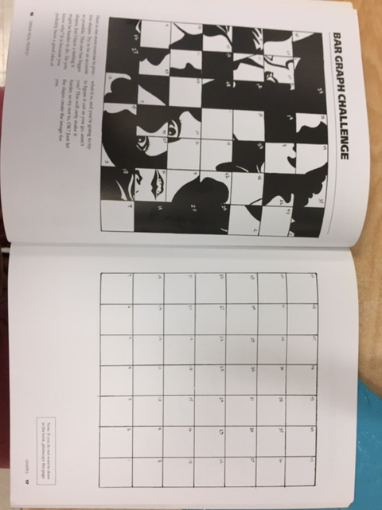
Practice the above gridded drawing by translating what is in each coordinate on the blank grid.

Choose one of the following: easy, medium, or hard face to draw. Draw a grid with the same number of coordinated in your sketch book and draw the contour lines of the face. It should fill an entire sketchbook page.
