Sculpture 1 Project Assessment Rubric- Ms. Tucker Gravatt
Student Name: | Class Period:
Project: Paper Mache Mounted Animal | Date:

Circle the number in pencil that best shows how well you feel that you completed that criterion for the assignment. | Excellent  (A)  Above standard | Good  (B)  Meets all standard objectives well | Average  (C)  Meets all standard objectives with help | Needs  Improvement  (D)  Below standard | Rate  Yourself | Teacher’s  Rating
Criteria 1: I understand the role of planning in solving artistic problems and have constructed an animal armature using the assemblage process with cardboard and other recyclable materials. I worked from a detailed sketch I drew. | 20 | 19 – 18 | 17 – 16 | 15 or below
Criteria 2: B.CX.1.1 I understand the tradition of paper mache and have successfully added 2 layers of paper towel and 2 layers of newspaper to create a sturdy foundation (skin) for the animal. Lines are smooth and follow the shape of the body with nothing sticking out where it doesn’t below. | 20 | 19 – 18 | 17 – 16 | 15 or below
Criteria 3: B.V.2.3 I understand the role of creating original artwork and showing visual expression. I have successfully painted my animal to match colors and texture needed with paint. If needed, I have applied other found materials or clay pieces to enhance the animals appearance without taking away from the design. | 20 | 19 – 18 | 17 – 16 | 15 or below
Criteria 4: Technical Skill: How well have you executed the construction skills for your animal? How well is the paper mache? And painting? Your craftsmanship is important; did you take your time? | 20 | 19 – 18 | 17 – 16 | 15 or below
Criteria 5: Participation: How well have you put forth effort on this project? In class and outside of class on this assignment? | 20 | 19 – 18 | 17 – 16 | 15 or below

Total Points Possible: 100 | Your Total: | Teacher Total:
Written Points Added below Possible: -10 if not completed
Combined Total for Final Grade: 100 Possible

Written assessment: (must be in complete sentences) What are your strengths/ improvements/ things learned?

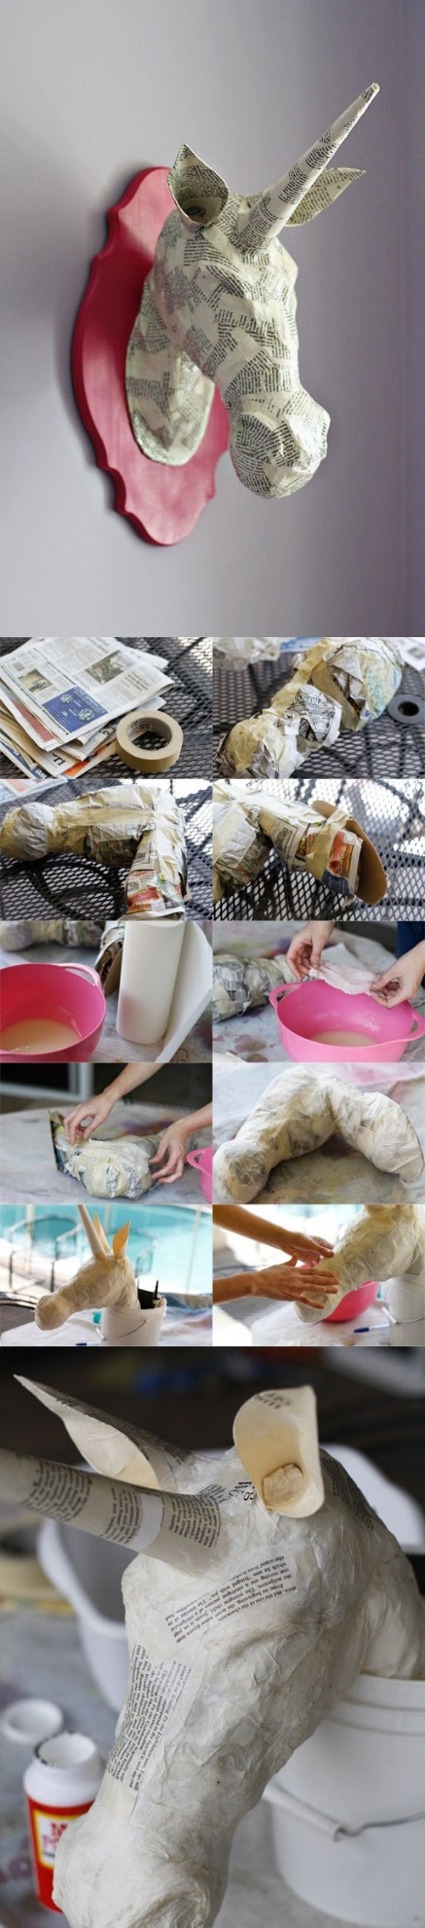
Animal armature shown below

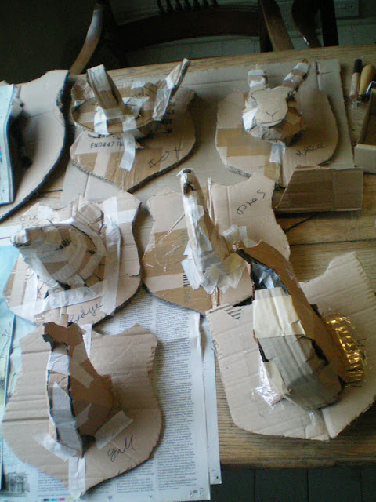

Finished Animal Mount shown below

