Right Brain vs. Left Brain

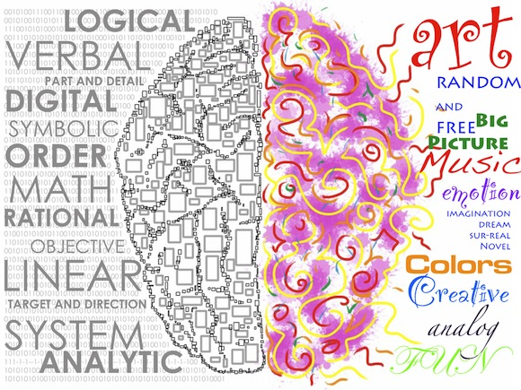
Left-brain oriented learners tend to like structure, focus on details, enjoy organization and logic, and are able to express themselves with words. Memorization comes easily, and left-brained learners tend to learn best by repetition. These children work effectively with a step-by-step sequential approach, like to work independently, have a strong sense of time, and are objective. Writing and spelling generally come easily to these learners, and they tend to learn well from instruction. Arithmetic, with its logical, sequential steps, is also a subject in which left-brained children often excel, although conceptual mathematical subjects such as geometry may be challenging. Left-brained children tend to benefit from an auditory teaching style, and often demonstrate academic aptitude early on.
Right-brain oriented learners, on the other hand, are visual. They focus on holistic concepts rather than details, tend to be unstructured and impulsive, and are usually very creative, often demonstrating proficiency in art or music. These child do not enjoy working independently; they learn best from discussion, interaction, cooperation and involvement with whatever they are learning. Right-brained children think in pictures rather than words, generally have a good sense of spatial orientation (but not a good sense of time), and are attuned to emotions. These children prefer the main idea to the details, and often learn in spurts rather than in a steady sequence. Right-brain oriented learners often come to conclusions intuitively, without knowing the steps by which they got to the answer, and often prefer a visual and/or kinesthetic teaching style. It is not uncommon for right-brain oriented children to be “late bloomers” academically.
Which type of personality or learning style do you have?
Take the quiz on my website: http://tuckerartists.weebly.com/class-info-links.html
It is under Art 1 class info.
Or go directly to YouTube video: https://youtu.be/feAikjPqOq8

Write your answers below:

Reflection: In a few sentences below describe if you agree or disagree with the finding of taking this quiz.

