Pin/Needle Tool  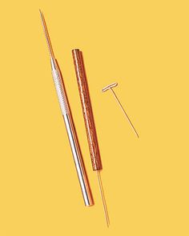 | Ribbon Tool  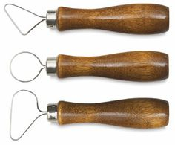 | Rib  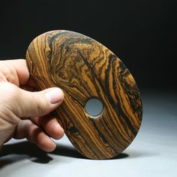 | Sponge  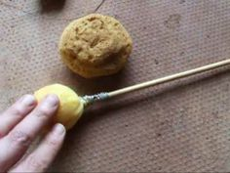
Slack Bucket  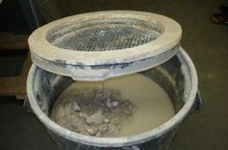 | Plaster Batt- for drying out clay  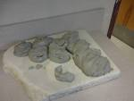 | Potter’s Wheel  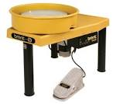 | Kiln  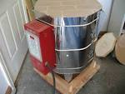
Wire Cutter  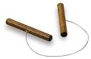 | Glaze  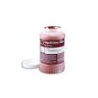 | Coil Pot (hand built) 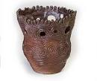 | Slab (hand built)  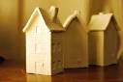
Pinch Pot (hand built)  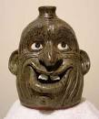* Face Jug | Wheel Pot  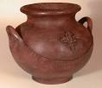 | Body | Foot
Handle | Rim | Score- scratch marks for joining clay  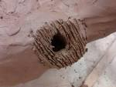 | Slip- watered down clay  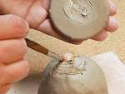
Greenware  - all clay before it’s fired | Bisque  - clay fired once at low temperature; Cone 04 | Glaze Fired  - clay has been fired twice with an application of glaze | Bone Dry  - all water has evaporated from clay, clay much lighter color.
Leather Hard  - clay has begun to set, you can still add pieces of like hardness, clay still dark color. | Clay Thickness:  Must be ¼ to ½ inch thick throughout design | Air Pocket/Bubble  - Trapped air that will explode clay in the kiln. | Piercing  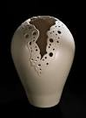
Relief- carving away the background to show different levels of elevation. This creates depth and space.  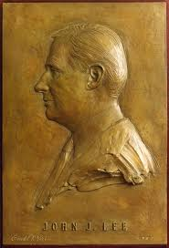 | Modeling- All the additive hand building techniques. | Mobile- is a type of kinetic sculpture that consists of weighted objects that hang suspended in air from supports  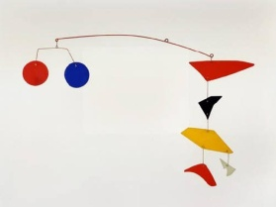 | Sculpture in Round- is a free-standing type of sculpture, such as a statue.  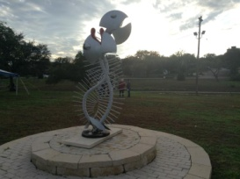
Carving-removing material to create your form or design. 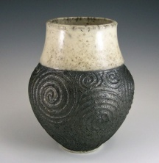 | Assemblage- affixing found objects or pieces of material together one by one. 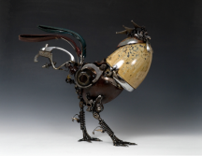 | Kinetic- contains moving parts or depends on movement for its full visual effect. | Space-area within and surrounding the artwork.  Mass- bulk of the body of the sculpture, space occupying material.
Repurpose- When an object no longer is being used for its original purpose and is used for something else. | Additive- creating sculpture by adding material. | Subtractive- removing or carving out material to create your piece of art. | Origami- A type of paper folding that originated from Japan.  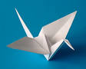
Texture-  Actual  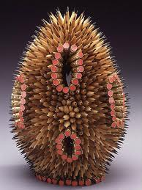  implied | Movement-how your eye travels through the artwork.  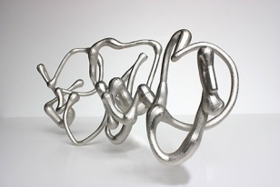 | Contrast- the difference of opposite elements (light/dark, rough/smooth textures, thick/thin).  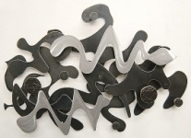 | Unity- sense of oneness or wholeness-as if they belong together.
Balance- (symmetrical) 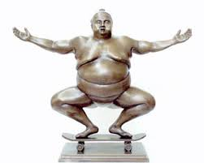  (Asymmetrical) 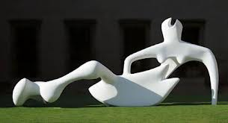 | Emphasis-  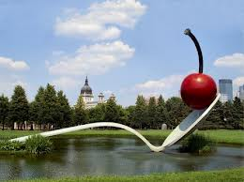 | Pattern- repetition of the same element.  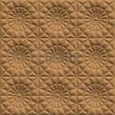 | Rhythm- repeating similar elements to create movement. 