MINI PROJECT MASTER “re-do”
Student name________________________________________
Emphasis on Dominant use of an Element or Principle of Design

Choose your favorite mini project from the beginning of the semester to use as a three dimensional sketch for a reworked/ redone/ and remastered project.
You must enlarge the size of the project by at least 4 times it’s original size.
You must work in the same type of medium you used for your mini project.
You must keep the majority of the general shape of the form, but you may make altercations to improve it to emphasize the element or principle of design you are supposed to be emphasizing. Also, I gave you several suggestions to improve the form on the mini project, you should be making those improvements on this larger project.
Remember to look back on the original expectations and objectives for the mini project to make sure you are meeting the expected criteria. Other than size, it should remain the same.
Craftsmanship is very important, choose a mini project that had a material you liked working with and make sure it is constructed well.

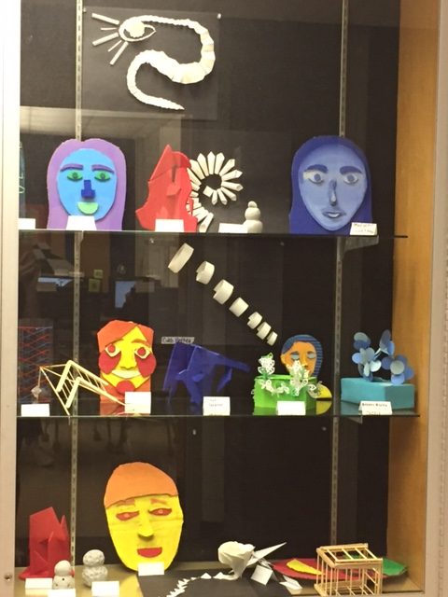 | Rubric:  10= more than expected 9,8= met objective well 7,6= met objective with help, could improve 5= did not meet objective Rate yourself Teacher rating  Project is at least 4 times larger than your mini project.  Project shows a dominant element or principle.  Project was reworked to be improved and more successful.  How are your technical skills?  Participation: did you research images on your own for reference? Did you follow your sketch plan?  Totals: 50 (x2)= 100 possible
**********Writing reflection: In three complete sentences describe your strengths, improvements, and things you learned while completing this project. What element of principle of design are you showing? (-5pts if not completed correctly)

