Student name: ________________________________________________________________
Objective: You will write three questions for a review test. They are all multiple choice. One must be to choose the correct definition or vocab word. One must have images that you have drawn for the choices and one must have pictures that you have found online or in magazines. You are writing the question and the answer choice. See example below:
- The path of a moving point describes what element of design?
  - Shape
  - Line
  - Value
  - Road

- Which image best represents hatching?
 | - 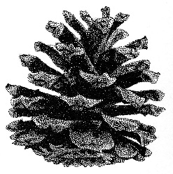
- 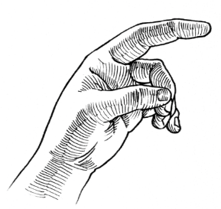 | - 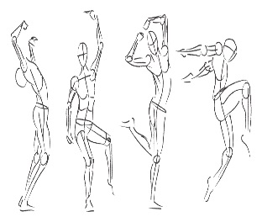

- Which image best represents symmetrical balance?
a. 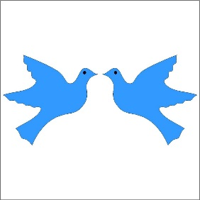 | b.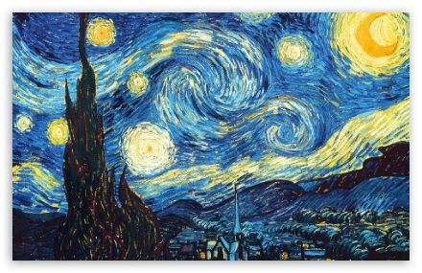
c. 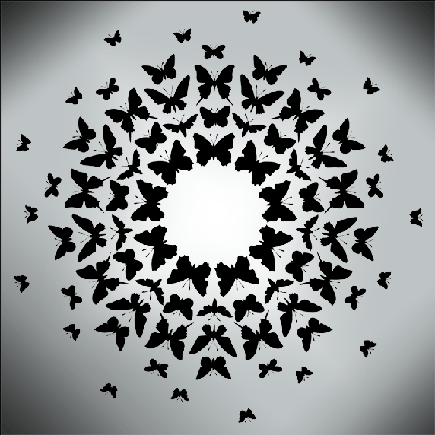 | d. 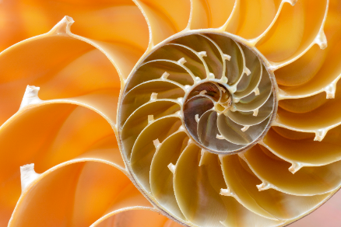

Write in the questions and answers very neatly please!
- __________________________________________________________________________________________________________________________________________________________________________________________________________________________________________
  - ____________________________________________
  - ____________________________________________
  - ____________________________________________
  - ____________________________________________

- __________________________________________________________________________________________________________________________________________________________________________________________________________________________________________
a. | b.
c. | d.

- __________________________________________________________________________________________________________________________________________________________________________________________________________________________________________
a. | b.
c. | d.

