Subtractive Sculpture (Plaster carving)
Primary Emphasis: Three-dimensional Form "In the Round"
Secondary Emphasis: Positive and Negative Space, (figure and ground)
The alternating employment of shallow and deep cuts through the plaster should be used to create different levels of light tonality. Texture is also important in creating interest, since different textures will reflect the light in a different manner, contributing thus in the creation of a rich design.

Notes
- Cover the tables with brown paper or newspapers while you carve.
- Cleanup after you are done.
- Dress for a mess!
- Plaster will be provided by the studio.
- Use ONLY the assigned chisels to carve plaster (the moisture in plaster will ruin any good chisel).

Materials
- A small plastic bucket for plaster mixing.
- 2-3 Plastic garbage bags (small) to line your bucket.
- Plastic or paper container for plaster casting (it might be necessary to cut it away from the plaster). Milk or large soda bottles are good for such use.
- A stack of old newspapers or brown paper. You must absolutely cover your table during carving.
- Carving tools of your choice (i.e. old utensils, old screwdrivers, wood files, knives). Old Wood chisels are ideal. Remember that plaster contains water and any steel tools will eventually rust.
- Sandpaper for smoothing the surface during the final stages. The degree of smoothness you desire will determine the sandpaper grit you will need. Get a pack of assorted grits. Ideally you will need one of each: 80, 100, 220, 400, and 600 grit.

Plaster Carving - General Information
When carving a form in any material two methods can be employed. The carver can either let the original mass determine the nature of the carved form by working intuitively and making adjustments during the process, or he/she can determine the nature of the form prior to carving. A combination of the two methods is also used often. In this case the sculptor will loosely conceive of a form to be carved out and during the process of carving he or she will make various adjustments and changes to the original plan.
Carving is a methodical and time-consuming activity. It demands patience and a great deal of focus since the carved material is always prone to breaking when the sculptor is careless. In this sense, the sculptor is required to become one with his material and to anticipate the intentions of its object before any accidents occur.
The carving technique is universal for all material in the way that the sculptor will remove first the large unwanted portions of mass before proceeding to break smaller and smaller pieces as he/she approaches the surface of the desired forms. The final stages of the form revelation often involve careful and time consuming sanding, polishing, and depending on the material, finishing the sculpture by sealing its surface.

Finishing plaster
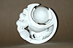
Plaster is offered for a wide variety of finishes and it can be textured, smoothed in various degrees, painted, or waxed. Plaster's white color and silky texture invites attention even without any extra finishing, and if presented indoors it can even be left unsealed. If the plaster is to be presented outdoors, then a sealing coat of shellac (diluted 1:1 with denatured alcohol) followed with a coat of "butcher's wax" is advised. Plaster is a porous material and as such it is a good ground for paint. It can be colored with watercolors, acrylics, or its surface can be rubbed with pastels and even oil colors. For a dramatic effect of emphasizing its texture, powder graphite can be rubbed on the surface with a soft cloth.
Plaster can take a good polish by methodic sanding. Begin with a rough grid (80 or 100 will do fine), and work the polish up with successive passes of finer and finer sandpaper and finish by "wet-sanding" the surface with 600 or even 1200 grid sandpaper.
In order to paint or seal the surface, the plaster must be thoroughly dry for a period of about 2 weeks (depending on the humidity and temperature).

Plaster Stages
From the moment you begin to mix until it is set, plaster goes through a number of stages:
1. The liquid stage: This stage occurs immediately after mixing with water. The mixture at this stage can be poured, brushed and thrown. It lasts about 15 minutes.
2. The putty stage: The plaster thickens to the consistency of toothpaste. In this stage, plaster can be applied with a putty knife or spatula, and it can be modeled like clay. It lasts about 5 minutes.
3. The rigid stage: Occurs once the mixture begins to set. The plaster becomes brittle and it can be cut with a knife or dug into with a spoon. The plaster is very fragile and should not be vibrated, dropped or have pressure on it.
4. The set stage: The plaster begins to heat up and obviously hardens. The heat that is radiated depends on the size of the mixture and the setting speed. When the plaster cools, it is a good time to remove it from the mold and trim any unwanted edges since it is still very pliable.
5. The cure stage:
Lasts from the time the plaster cools until it dries completely. The mixture hardens substantially and metal tools are required for its manipulation. Because it still contains about 18% water, the tools get clogged and require cleaning quite often.
6. The dry stage:
The plaster no longer contains moisture and it is at maximum strength and very brittle at this stage. It can be sanded with sandpaper or painted.
Safety
Plaster is a safe material to work with. You might want to use a face mask while you mix plaster, and if your skin is sensitive and dry, use a pair of latex gloves. Once the plaster sets, the only danger might come from the mass falling on your foot (be careful!), and from sharp carving instruments. Always carve away from your body!
Lesson Adapted from Thomas Sakoulas, State University of New York at Oneonta: Art Department
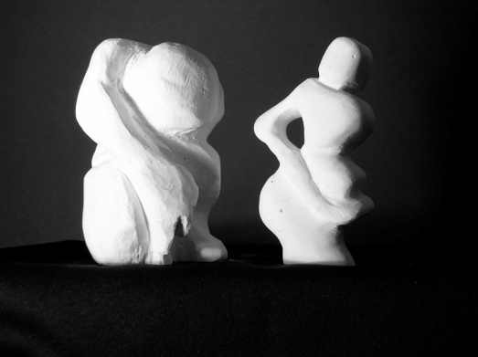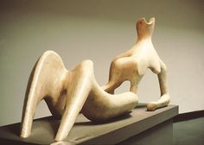
Student work Henry Moore
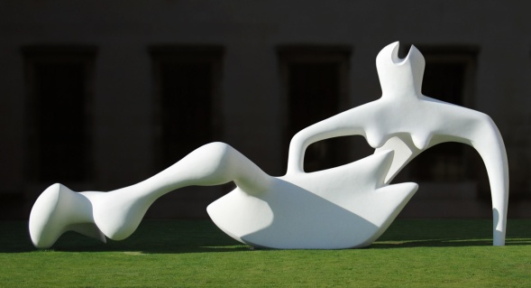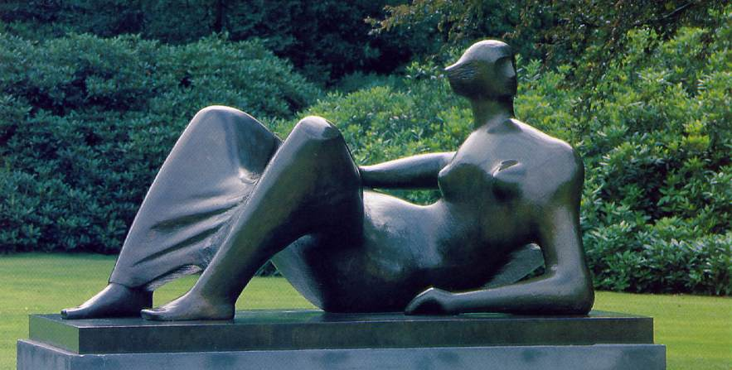
Henry Spencer Moore (30 July 1898 – 31 August 1986) was an English sculptor and artist. He was best known for his semi-abstract monumental bronze sculptures which are located around the world as public works of art. His forms are usually abstractions of the human figure, typically depicting mother-and-child or reclining figures. Moore's works are usually suggestive of the female body, apart from a phase in the 1950s when he sculpted family groups. His forms are generally pierced or contain hollow spaces. Many interpreters liken the undulating form of his reclining figures to the landscape and hills of his birthplace, Yorkshire.
Sculpture 2 Project Assessment Rubric- Ms. Tucker
Student Name: | Class Period:
Project: Plaster Subtractive Sculpture | Date:

Circle the number in pencil that best shows how well you feel that you completed that criterion for the assignment. | Excellent  (A)  Above standard | Good  (B)  Meets all standard objectives well | Average  (C)  Meets all standard objectives with help | Needs  Improvement  (D)  Below standard | Rate  Yourself | Teacher’s  Rating
Criteria 1: I understand that art making involves planning and precision. I have successfully demonstrated my knowledge of subtractive sculpture and have a successfully carved plaster to match my mini clay maquette of an abstracted human figure. | 20 | 19 – 18 | 17 – 16 | 15 or below
Criteria 2: I understand the relationship between positive/negative (figure/ground) space and successfully constructed my sculpture to shape space in a thoughtful manor. | 20 | 19 – 18 | 17 – 16 | 15 or below
Criteria 3: Light is an important factor to consider in sculpture and reflection on surface plays into how light is being used. I have contrast in surface texture throughout my entire piece. | 20 | 19 – 18 | 17 – 16 | 15 or below
Criteria 4: Technical Skill: How well have you executed the carving skills for this sculpture? Are all surface texture areas intentional? | 20 | 19 – 18 | 17 – 16 | 15 or below
Criteria 5: Participation: How well have you put forth effort on this project? In class and outside of class on this assignment? Were your sketches approved before you started construction? | 20 | 19 – 18 | 17 – 16 | 15 or below

Total Points Possible: 100 | Your Total: | Teacher Total:
Written Points Added below Possible: -10 if not completed
Combined Total for Final Grade: 100 Possible

Write at least three complete sentences describing your strengths, things you could improve on, and things you learned.
Also include one element and principle of design that are dominant in your plaster design and how they are used: (10 pts possible)

