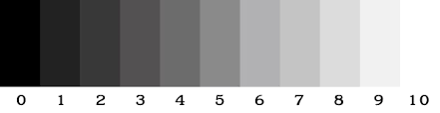
Value scale checker

0 | 1 | 2 | 3 | 4 | 5 | 6 | 7 | 8 | 9

Use graphite pencil to evenly shade each box like the value scale above.

Student name: ____________________________________________

Value scale checker

0 | 1 | 2 | 3 | 4 | 5 | 6 | 7 | 8 | 9

Use graphite pencil to evenly shade each box like the value scale above.

Student name: ____________________________________________

